PROGRAM FOR BASIC FORMULAS OF SHAPES:

import math

while True:
print("\n1. Radius of Circle")
print("2. Area of Square")
print("3. Area of Rectangle")
print("4.Exit")

choice = int(input("Choose an operation: "))

if choice == 1:
radius = float(input("Enter the Radius of Circle:"))
circle_area = math.pi * radius * radius
print("Radius of the circle =", round(circle_area))

elif choice == 2:
side = float(input("Enter the sides of Square:"))
area = side * side
print("Area of the square =", round(area))

elif choice == 3:
length = float(input("Enter the length of a rectangle: "))
width = float(input("Enter the width of rectangle"))
area = length * width
print("Area of the rectangle =", round(area))

elif choice == 4:
print("Program ended")
break

else:
print("Invalid choice")

OUTPUT FOR THIS PROGRAM:
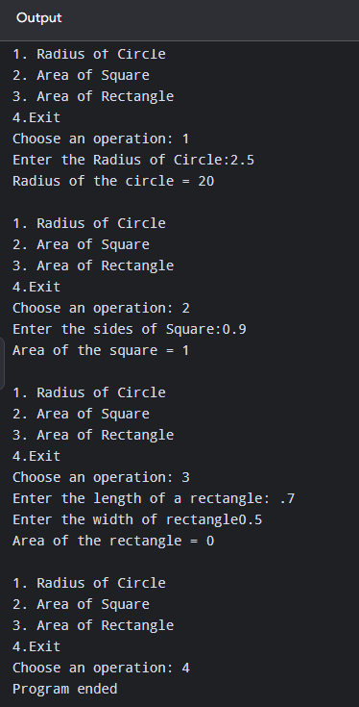
PROMPT FOR THIS PROGRAM:

Write a Python program using a menu-driven while loop to calculate the area of different geometric shapes.
The program should provide these options:
- Calculate the area of a circle
- Calculate the area of a square
- Calculate the area of a rectangle
- Exit the program
The program should accept numeric inputs such as integers or decimal (float) values from the user. Use appropriate datatype conversion such as float() for the input.

